NOMBRE DE LA MATERIA

Fundamentos de Redes

NOMBRE DEL DOCENTE

Rafael Preciado Gutiérrez

NOMBRE DEL TRABAJO

Actividad 3

NOMBRE DEL ALUMNO

Alejandro Guevara de Luna

UNIDAD

2

FECHA Y LUGAR

2 de octubre del 2022

Instituto Tecnológico de Pabellón de Arteaga

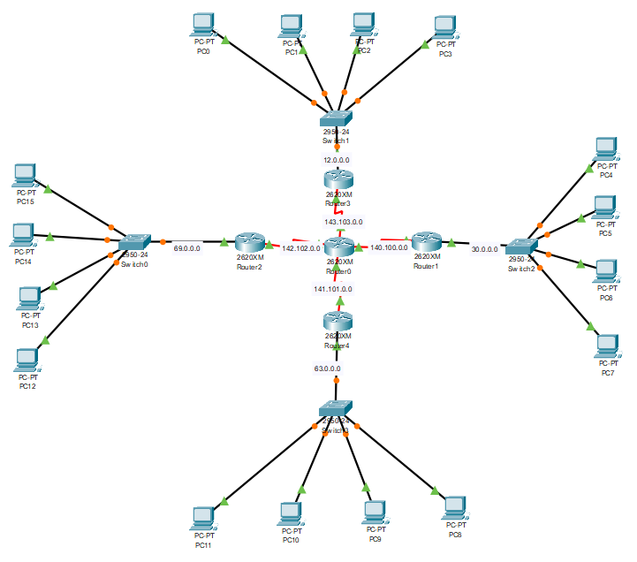

|  |  |  |  |  |
| --- | --- | --- | --- | --- |
| Dispositivo | Puerto | IPv4 | Mascara | Gateway |
| Router 1 | S 0/0 | 140.100.0.0 | 255.255.0.0 | NA |
| S 0/1 | 141.101.0.0 | 255.255.0.0 | NA |
| S 1/0 | 142.102.0.0 | 255.255.0.0 | NA |
| S 1/1 | 143.103.0.0 | 255.255.0.0 | NA |
| Router 2 | S 0/0 | 140.100.0.2 | 255.255.0.0 | NA |
| Fa 0/0 | 30.0.0.1 | 255.0.0.0 | NA |
| Router 3 | S 0/0 | 141.101.0.2 | 255.255.0.0 | NA |
| Fa 0/0 | 63.0.0.1 | 255.0.0.0 | NA |
| Router 4 | S 0/0 | 142.102.0.2 | 255.255.0.0 | NA |
| Fa 0/0 | 69.0.0.1 | 255.0.0.0 | NA |
| Router 5 | S 0/0 | 143.103.0.2 | 255.255.0.0 | NA |
| Fa 0/0 | 12.0.0.1 | 255.0.0.0 | NA |
| PC0 | Fa 0/0 | 30.0.0.2 | 255.0.0.0 | 30.0.0.1 |
| PC1 | Fa 0/0 | 30.0.0.3 | 255.0.0.0 | 30.0.0.1 |
| PC2 | Fa 0/0 | 30.0.0.4 | 255.0.0.0 | 30.0.0.1 |
| PC3 | Fa 0/0 | 30.0.0.5 | 255.0.0.0 | 30.0.0.1 |
| PC4 | Fa 0/0 | 63.0.0.2 | 255.0.0.0 | 63.0.0.1 |
| PC5 | Fa 0/0 | 63.0.0.3 | 255.0.0.0 | 63.0.0.1 |
| PC6 | Fa 0/0 | 63.0.0.4 | 255.0.0.0 | 63.0.0.1 |
| PC7 | Fa 0/0 | 63.0.0.5 | 255.0.0.0 | 63.0.0.1 |
| PC8 | Fa 0/0 | 69.0.0.2 | 255.0.0.0 | 69.0.0.1 |
| PC9 | Fa 0/0 | 69.0.0.3 | 255.0.0.0 | 69.0.0.1 |
| PC10 | Fa 0/0 | 69.0.0.4 | 255.0.0.0 | 69.0.0.1 |
| PC11 | Fa 0/0 | 69.0.0.5 | 255.0.0.0 | 69.0.0.1 |
| PC12 | Fa 0/0 | 12.0.0.2 | 255.0.0.0 | 12.0.0.1 |
| PC13 | Fa 0/0 | 12.0.0.3 | 255.0.0.0 | 12.0.0.1 |
| PC14 | Fa 0/0 | 12.0.0.4 | 255.0.0.0 | 12.0.0.1 |
| PC15 | Fa 0/0 | 12.0.0.5 | 255.0.0.0 | 12.0.0.1 |